PRUEBA SABER 11

PARTE 3

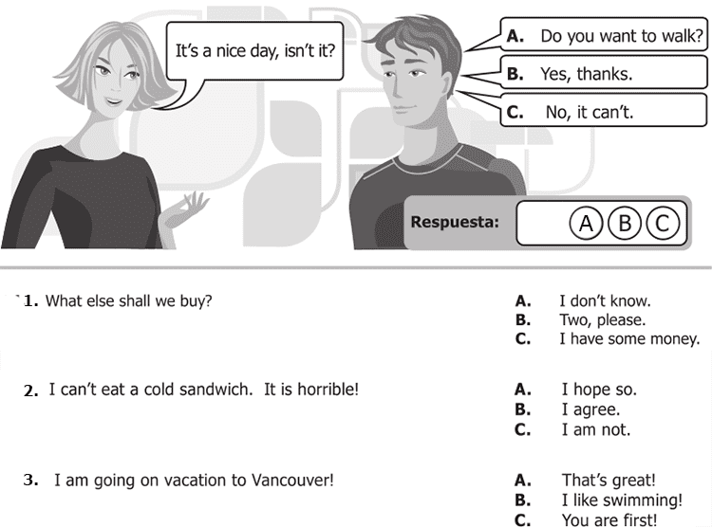

**7.** I can’t eat a cold sandwich. It is horrible! A. I hope so

B. I agree

C. I am not

**8.** I am going on vacation to Vancouver! A. That´s great!

B. I like swimming

C. You are first

**9.** It rained a lot last night! A. Did you accept?

B. Did you understand?

C. Did you sleep?

